How to verify the name of the Pscyhologist/Doctor to whom your Green’s program is registered:

WMT / AI within the GTP Program
- Open the GTP program, and enter your password then click OK
- After the password is entered the main window will open
- The bottom left shows the name of the registered Psychologist:
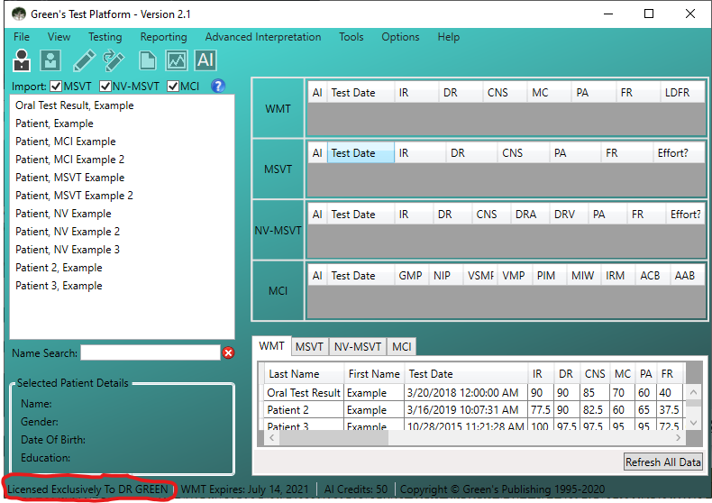

MSVT & NV-MSVT
- Open the MSVT / NV-MSVT program and enter your password then click OK
- From the main window, select Options Add Test Credits
- The Add Test Credits window will show the Doctor’s last name:
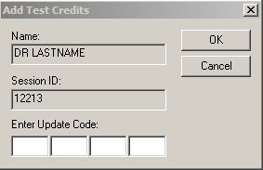

MCI
- Open the MCI program and enter your password then click OK
- From the patient list, select any patient that has previously been administered the MCI
- Then select Reporting menu Comparative Report
- In the new Comparative Report window that opens, click on Preview
- A preview of the Report should open. At the very bottom of the report, you will see
“This copy of Green’s MCI is licensed exclusively to LASTNAME”

AI & RSPT & EPT & LPT
- Open the program and enter your password then click OK
- From the main window, select Options menu Add Test Credits
- The Add Test Credits window will show the Doctor’s last name:
