Green’s Test Platform Crashes When Trying To Print A Report

Here is a workaround for this problem until we are able to solve this:
- In the Green’s Test Platform (GTP) select your patient from the patient list on the left
- Select Reporting Report Builder
  - Or select Reporting Chart Builder; or select Reporting Per-Question Report
- Make your desired changes on the Report Builder and then click the Preview button
- The Report will be shown. Click the Red X at the top-right to close the report
- Press the Windows Key and R key on your keyboard at the same time
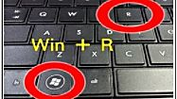
- Type %appdata% in the box
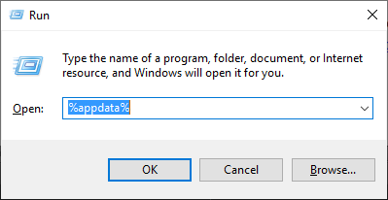
- Press OK. This will open a folder that says “Roaming” at the top
- Open the GTP folder
- Open the WMT folder
- Double-click on the file named "WmtReport"
- If the file opens with an "XPS Viewer" program then you should be able to print it from that program, otherwise:
  - You need to install an XPS Viewer to open the file (see https://www.microsoft.com/en-us/download/details.aspx?id=11816)

