How To Send Log Files When GTP Has An Error

- Press the Windows Key and R key on your keyboard at the same time
- Type %appdata% in the box
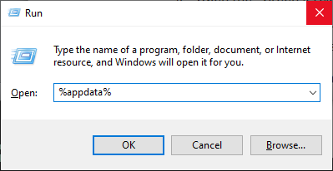
- Press OK. This will open a folder that says “Roaming” at the top
- Open the “GTP” folder
- There will be a file named “GTP_Log” and there might be a file called “GTP_Debug_Log”. Please email these files to us
  - Optionally, you can send us the database file which can be helpful for Green’s Publishing to solve problems. This file contains patient names and demographics. We will keep your information safe and delete the database file once we are finished with it. You can email the “GTP_DB” file to us if you wish to do this.
- If you don’t see the log files in that folder, then:
  - Press the Windows Key and R key on your keyboard at the same time
  - Type %programdata% in the box
  - Press OK. This will open a folder that says “ProgramData” at the top
  - Open the “Green’s Test Platform” folder
  - Send us the files as described in step #5 above

