How To Add Language Files To The Green’s Test Platform (GTP)

CONTACT INFO
International: +1 (236) 420-4351
Toll Free: 1 (844) 889-4538 (US & Canada)
Fax: +1 (236) 420-4981
GreensPublishing@gmail.com
GreensPublishing.com

FIRST, LOGIN TO THE SUPPORT SECTION OF OUR WEBSITE
- Go to www.greenspublishing.com
- Click on “Support” from the top menu bar
- Enter your email address and contact us for the password
- Click on “Login” and then click “Continue”
- Right click on the desired language file(s) and choose “Save As”, “Save Target As” or “Save Link As” and save these files to a known folder (i.e. Desktop or Downloads folder)
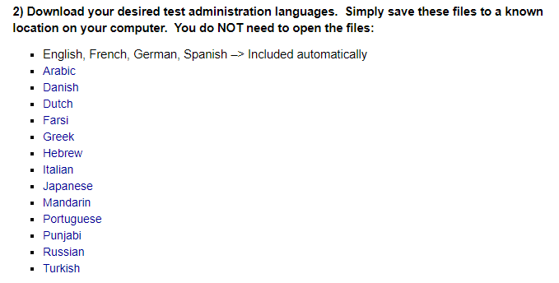
    - English, French, German and Spanish are included automatically. If you need to add them again for some reason, then scroll down and click on Additional Resources. You can also download the experimental English Form Two
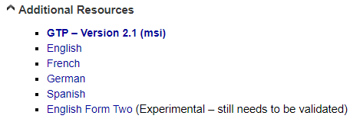
    - If you’re told to use earlier versions of the language files, you can scroll near the bottom of the page to these sections:
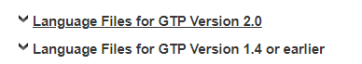
- Open the GTP program by double-clicking on the Green’s Test Platform icon from your desktop
- Enter your password and click OK
- From the menu at the top, click on Options Add Languages
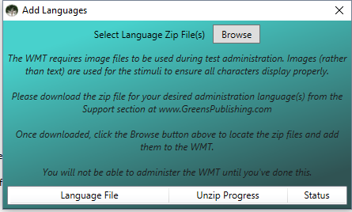
Click on “Browse”. In the new window that appears, browse to the folder where you saved the language files as described above. You can hold the CTRL Key on your keyboard to select multiple files at once. Then click the “Open” button. The files will begin unzipping. Once each language is added, a message will pop up saying they’ve been added successfully.

