HOW TO UN-INSTALL OR TRANSFER GREEN’S PROGRAMS TO ANOTHER COMPUTER

WMT / AI (Within the Green’s Test Platform Program)
In Windows 10, 8.1, 8:
- First, open the Green’s Test Platform Program from the desktop icon
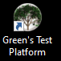
- Enter your password
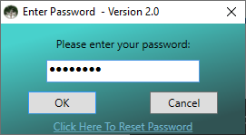
- Write down the WMT Expiry date and AI credits shown at the bottom of the main window. You will need to give these to a Green’s Publishing staff member
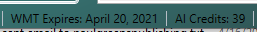
- Close the GTP program
- Click the Windows icon / start button in the bottom left of your screen
- Type Control Panel on your keyboard. You will see the Control Panel desktop app as a search result. Click on it
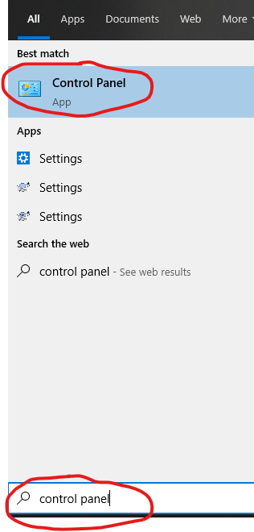
- In the Control Panel, click on Uninstall a program (located underneath the “Programs” or “Programs and Features” title). If you don’t see Uninstall a program, then click on Programs or Programs and Features.
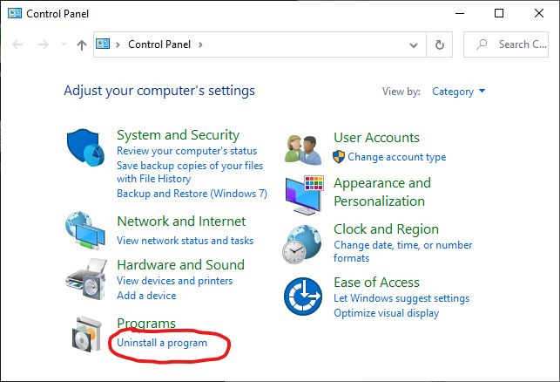
- Click on Green’s Test Platform in the list of programs and then click on Uninstall.
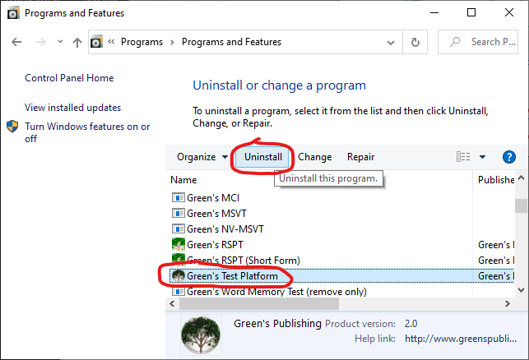
- An uninstallation wizard will appear. Follow through the steps of the wizard until the WMT is uninstalled
- Follow through the steps of the uninstallation wizard
- During Uninstall you will be asked if you want to transfer your license. Click on Yes if you want to transfer your WMT Expiry / AI Test credits to another computer. Otherwise, click on No
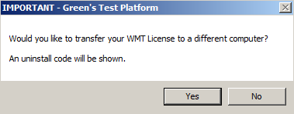
- If you clicked Yes, write down the uninstall code that is shown and provide it to Green’s Publishing
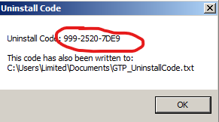

In Windows 7, Vista, XP:
  - First, open the Green’s Test Platform Program from the desktop icon
  - Enter your password
  - Write down the WMT Expiry date and AI credits shown at the bottom of the main window. You will need to give these to a Green’s Publishing staff member
  - Close the GTP program
- Click on Start then click on Control Panel
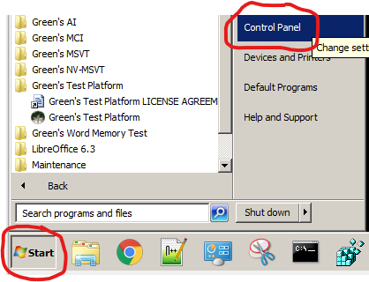
- Click on Uninstall a program
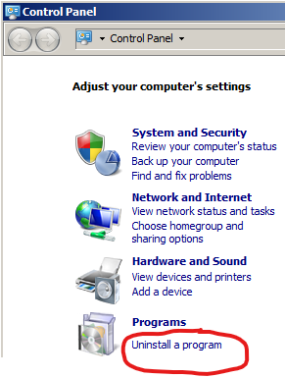
- Scroll down and click on Green’s Test Platform and then click on Uninstall
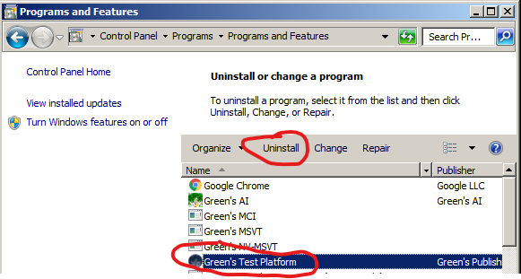
- Follow through the steps of the uninstallation wizard
- During Uninstall you will be asked if you want to transfer your license. Click on Yes if you want to transfer your WMT Expiry / AI Test credits to another computer. Otherwise, click on No
- If you clicked Yes, write down the uninstall code that is shown and provide it to Green’s Publishing

MSVT
- Open the MSVT program.
- On the main window of the program, look in the bottom-right corner for the number of Test Credits Remaining. Write down this number.
- Close the MSVT program.
- In Windows XP, Vista or 7: Click on Start -> Programs (or All Programs) -> Green’s MSVT (this is a folder) -> Uninstall Green’s MSVT.
In Windows 8, 8.1 or 10: Click on Start, then type Control Panel on your keyboard. You will see the Control Panel desktop app as a search result. Click on it. In the Control Panel, click on Uninstall a program (located underneath the “Programs” or “Programs and Features” title). If you don’t see Uninstall a program, then click on Programs or Programs and Features. Click on Green’s MSVT in the list of programs and then click on Uninstall.
- An uninstallation wizard will appear. Follow through the steps of the wizard. Choose “No” when asked to delete all patient data (don’t worry – if you accidentally choose “Yes” your data is still saved).
- An uninstall code will be displayed – please write down this code and provide it to a Green’s Publishing representative.

NV-MSVT
- Open the NV-MSVT program.
- On the main window of the program, look in the bottom-right corner for the number of Test Credits Remaining. Write down this number.
- Close the NV-MSVT program.
- In Windows XP, Vista or 7: Click on Start -> Programs (or All Programs) -> Green’s NV-MSVT (this is a folder) -> Uninstall Green’s NV-MSVT
In Windows 8, 8.1 or 10: Click on Start, then type Control Panel on your keyboard. You will see the Control Panel desktop app as a search result. Click on it. In the Control Panel, click on Uninstall a program (located underneath the “Programs” or “Programs and Features” title). If you don’t see Uninstall a program, then click on Programs or Programs and Features. Click on Green’s NV-MSVT in the list of programs and then click on Uninstall.
- An uninstallation wizard will appear. Follow through the steps of the wizard. Choose “No” when asked to delete all patient data (don’t worry – if you accidentally choose “Yes” your data is still saved).
- An uninstall code will be displayed – please write down this code and provide it to a Green’s Publishing representative.

MCI
- In Windows XP, Vista or 7: Click on Start -> Programs (or All Programs) -> Green’s MCI (this is a folder) -> Uninstall Green’s MCI
In Windows 8, 8.1 or 10: Click on Start, then type Control Panel on your keyboard. You will see the Control Panel desktop app as a search result. Click on it. In the Control Panel, click on Uninstall a program (located underneath the “Programs” or “Programs and Features” title). If you don’t see Uninstall a program, then click on Programs or Programs and Features. Click on Green’s MCI in the list of programs and then click on Uninstall.
- An uninstallation wizard will appear. Follow through the steps of the wizard until the MCI is uninstalled.

AI (The standalone program that is NOT inside the Green’s Test Platform)
- Open the AI program.
- On the main window of the program, look in the bottom-left corner for the number of Test Credits Remaining. Write down this number.
- Close the AI program.
- In Windows XP, Vista or 7: Click on Start -> Programs (or All Programs) -> Green’s AI (this is a folder) -> Uninstall Green’s AI. In Windows 8, 8.1 or 10: Click on Start, then type Control Panel on your keyboard. You will see the Control Panel desktop app as a search result. Click on it. In the Control Panel, click on Uninstall a program (located underneath the “Programs” or “Programs and Features” title). If you don’t see Uninstall a program, then click on Programs or Programs and Features. Click on Green’s AI in the list of programs and then click on Uninstall.
- An uninstallation wizard will appear. Follow through the steps of the wizard. When asked if you would like to transfer credits to a different computer, select “YES” if you wish to transfer them and write down the Uninstall Code when it is displayed. Provide the # of Test Credits Remaining and the Uninstall Code to a Green’s Publishing representative.
RSPT
- Open the RSPT program. Write down the # of test credits remaining from the bottom left corner of the program.
- Close the RSPT program.
- In Windows XP, Vista or 7: Click on Start -> Programs (or All Programs) -> Green’s RSPT (this is a folder) -> Uninstall Green’s RSPT. In Windows 8, 8.1 or 10: Click on Start, then type Control Panel on your keyboard. You will see the Control Panel desktop app as a search result. Click on it. In the Control Panel, click on Uninstall a program (located underneath the “Programs” or “Programs and Features” title). If you don’t see Uninstall a program, then click on Programs or Programs and Features. Click on Green’s RSPT in the list of programs and then click on Uninstall.
- An uninstallation wizard will appear. Follow through the steps of the wizard. When asked if you would like to transfer credits to a different computer, select “YES” if you wish to transfer them and write down the Uninstall Code when it is displayed. Provide the # of Test Credits Remaining and the Uninstall Code to a Green’s Publishing representative.
EPT
- Open the EPT program. Write down the # of test credits remaining from the bottom left corner of the program.
- Close the EPT program.
- In Windows XP, Vista or 7: Click on Start -> Programs (or All Programs) -> Green’s EPT (this is a folder) -> Uninstall Green’s EPT. In Windows 8, 8.1 or 10: Click on Start, then type Control Panel on your keyboard. You will see the Control Panel desktop app as a search result. Click on it. In the Control Panel, click on Uninstall a program (located underneath the “Programs” or “Programs and Features” title). If you don’t see Uninstall a program, then click on Programs or Programs and Features. Click on Green’s EPT in the list of programs and then click on Uninstall.
- An uninstallation wizard will appear. Follow through the steps of the wizard. When asked if you would like to transfer credits to a different computer, select “YES” if you wish to transfer them and write down the Uninstall Code when it is displayed. Provide the # of Test Credits Remaining and the Uninstall Code to a Green’s Publishing representative.
LPT
- Open the LPT program. Write down the # of test credits remaining from the bottom left corner of the program.
- Close the LPT program.
- In Windows XP, Vista or 7: Click on Start -> Programs (or All Programs) -> Green’s LPT (this is a folder) -> Uninstall Green’s LPT. In Windows 8, 8.1 or 10: Click on Start, then type Control Panel on your keyboard. You will see the Control Panel desktop app as a search result. Click on it. In the Control Panel, click on Uninstall a program (located underneath the “Programs” or “Programs and Features” title). If you don’t see Uninstall a program, then click on Programs or Programs and Features. Click on Green’s LPT in the list of programs and then click on Uninstall.
- An uninstallation wizard will appear. Follow through the steps of the wizard. When asked if you would like to transfer credits to a different computer, select “YES” if you wish to transfer them and write down the Uninstall Code when it is displayed. Provide the # of Test Credits Remaining and the Uninstall Code to a Green’s Publishing representative.

