Save Reports and Charts as PDF
In order to save any reports/charts/flowcharts to a PDF file in any of Green’s programs, you can use a PDF “Printer”, or XPS Document Writer. You may already have one of these installed, without even knowing it. To see if you have one installed, open the relevant Green’s Program, then open the Report/Chart/Flowchart you wish to print. There will be a list of Printers that you can choose to “print” to. See if any of the printers have the word “PDF” or “XPS” in them.
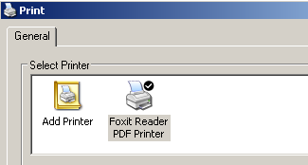
If so, select that printer and click the OK button to “print” to it (if you don’t see one, skip to the next paragraph). A new window should open asking you where you want to save the report/chart/flowchart as a PDF file or as an XPS file. Choose the location where you wish to save the file and enter the desired file name. Next, click on Save to save the file. If you don’t have a physical printer installed on your current computer, you can transfer this saved file to a different computer that has a physical printer, and then print this file from that computer.
If you don’t have a PDF Printer or XPS Document Writer installed, then you can download a PDF Printer. A PDF Printer will allow you to “print” to a PDF file instead of printing to a physical printer.
Green’s Publishing recommends using Foxit Reader as a PDF Printer. Foxit Reader can be downloaded and installed from http://www.foxitsoftware.com/downloads/. (Note that Foxit Reader runs on Windows XP even though it states that it is not officially supported).
During installation, you can uncheck all of these options since they are not needed to save PDF’s from Green’s programs (however, if you want these options for other programs you can certainly choose them):
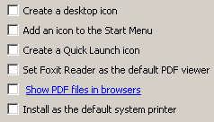
You will also be asked if you want a free trial of Foxit PhantomPDF, make sure you don’t install this trial.
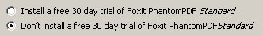
After Foxit Reader is installed, you can return to your Green’s program. You can begin printing the report/chart/flowchart as you normally would, however you will now be able to select Foxit Reader PDF Printer as the “Printer”.
Once you have selected Foxit Reader PDF Printer as the Printer, click on Print. You will then be asked where you want to save the PDF file. Choose a location and click on Save. You can now open the PDF file in the same way as you would open any other PDF file.

