HOW TO COPY WMT DATA FROM GREEN’S
TEST PLATFORM TO ANOTHER COMPUTER
Note: In this documentation, Computer “A” refers to the source computer that you wish to copy data from. Computer “B” refers to the destination folder that you wish to copy data to. If you are copying data from User Account “A” to User Account “B” on the same computer, then you can also follow these instructions.

WMT / Green’s Test Platform (GTP)

Via database file from the Application Data Directory:
Disclaimer: This will copy all data including per-question responses. However, it will ERASE AND OVERWRITE any WMT data that is already present on Computer B.
- On Computer A, close the GTP program if it is open
- Press the Windows key and R key at the same time on your keyboard
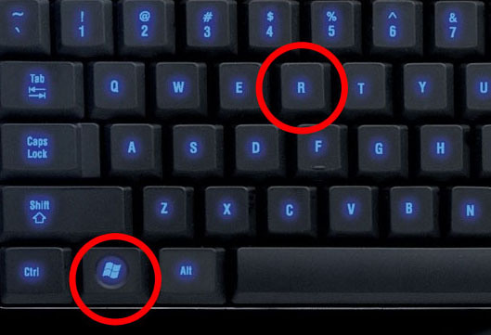
- Type %APPDATA% into the text box then press OK
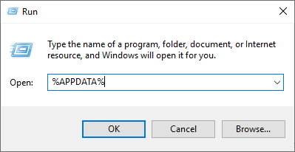
- You should now be looking in your Roaming folder. Double-click on the GTP folder
- Copy the GTP_DB file from this folder to a USB stick
- Transfer the USB stick to Computer B
- If you haven’t already done so, please install the GTP on Computer B. See our other document entitled How To Install Green’s Programs From. After the GTP is installed, close the GTP program
- Next, repeat steps 1 through 4 from above (on Computer B). You should now be in the %APPDATA%\GTP folder
- Open a 2nd File Explorer Window and select your USB stick. Copy the GTP_DB file from the USB stick and paste it to the %APPDATA%\GTP. Select Yes if asked to overwrite the file.
- Open the GTP program and verify all data has been imported.
- If you have multiple user accounts on Computer A that have WMT data in the GTP program, then please repeat all the above steps from the other user account(s)

Via Export All Data:
Disclaimer: This will NOT import per-question responses. However, any WMT data that is present on Computer B will remain intact and be combined with the data copied from Computer A. If the GTP is no longer installed on Computer A, please skip ahead to Option C).
- On Computer A, open the GTP program. Enter your password and click OK
- In the main window of the GTP, select Reporting Export All Data
- In the new window that appears, change the Save in location to a USB stick (or any other medium that is accessible by both computers such as a shared network folder)
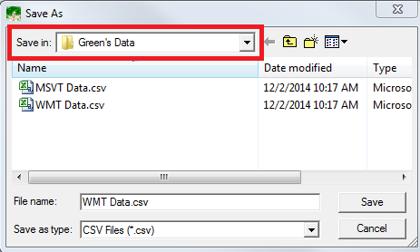
- Click the Save button.
- Eject the USB stick from Computer A, and plug it into Computer B
- On Computer B, open the GTP program and select File Import From Backup
- Change the Look in location to your USB stick (or the shared medium chosen in step 3)
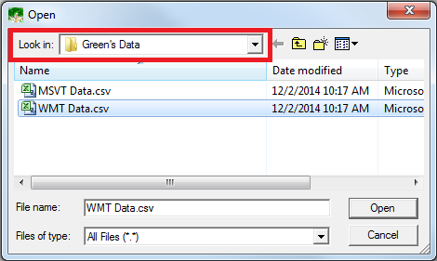
- Click on the file (likely named WMT Data.csv)
- Click the Open button
- If there is quite a lot of data to be imported, it may take 5 to 10 seconds or more. Please be patient. The WMT may appear to be frozen or not responding at this time, however this is not true
- If you have multiple user accounts on Computer A that have WMT data in the GTP program, then please repeat all the above steps from the other user account

Via .bak backup files:
Disclaimer: This will NOT import per-question responses. However, any WMT data that is present on Computer B will remain intact and be combined with the data copied from Computer A
- On Computer A, open the WMT folder from within your Documents folder (OR if you changed the Automatic backup directory from Options -> Preferences then open that folder)
- There should be several files named WMT######.bak
- The first 2 numbers represent the year, the next 2 are the month and the last 2 are the day (for example WMT130102.bak is from January 2, 2013)
- Copy the most recent .bak file to a USB stick
- Transfer the USB stick to Computer B
- Open the WMT program on Computer B and choose File -> Import From Backup
- Browse to find the .bak file on your USB stick and click on Open
- If you have multiple user accounts on Computer A that have WMT data in the GTP program, then please repeat all the above steps from the other user account

