MCI Data – Not Showing up in AI Program

- Verify you have the latest version of the AI / GTP Installed
  - If you are using the AI Inside the Green’s Test Platform (GTP) then you will have GTP version 2.0 OR LATER. To verify this, open the GTP and select Help About to view the version. If for some reason you have an earlier GTP version, then see our other document entitled “How to install Green’s programs from the website”. Updating to version 2.0 OR LATER should fix the problem. However, if the problem still exists, please proceed with the following steps.
  - If you are using the old AI standalone program then open the AI program and select Help About Green’s AI. This will display the AI version. If your AI version is not 5.0, then please install the Green’s Test Platform (see our other document entitled “How to install Green’s programs from the website”). Using the AI in the Green’s Test Platform should fix this problem. However, if the problem still exists, please proceed with the following steps.

- In the MCI Program, select Options Automatic Backup
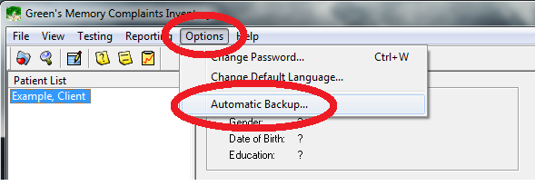

- In the “Automatic backup” window that appears, select the small button with the ellipsis
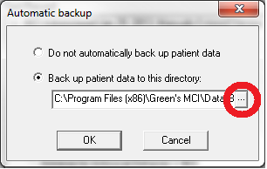

- In the “Browse For Folder” window that appears, look for the “MCI” folder under Libraries Documents My Documents MCI. (If you can’t find the folder here, move on to step 4).
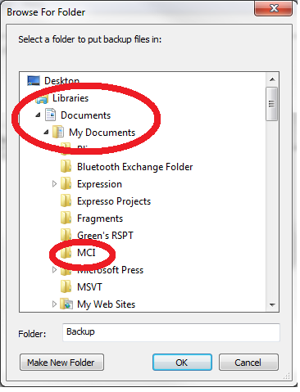

- If you can’t find the MCI folder in step 3, then in the same “Browse For Folder” window, look for the “MCI” folder under Computer OS (C:) Users [User_Name] My Documents MCI (note that [User_Name] is your username on your computer).
- Click the “OK” button.
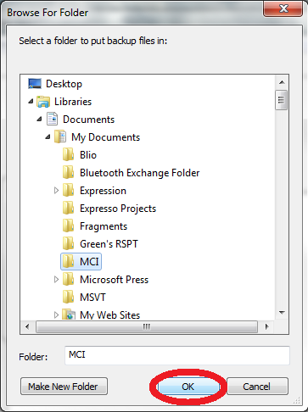

- Click “OK” on the “Automatic Backup” window
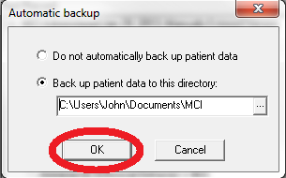

- Close the MCI Program (also close the GTP / AI program if it is open). Then open the GTP / AI program.

- Now, after every time you close the MCI program, all of your MCI data will be saved to the MCI folder within your My Documents directory. The AI will automatically load all of this MCI data (note: if you don’t see your most recent MCI data in the GTP / AI program, try closing and then re-opening the GTP / AI program).

