How to Update Green’s Test Platform / Word Memory Test / Advanced Interpretation to the Latest Version

*You can update to the latest version on your own. You do not need to contact us unless you run into problems. Your Patient data and test results will remain intact. Your WMT Expiry date will remain the same.

- Close the Green’s Test Platform (GTP) program if you have it open
- Go to www.greenspublishing.com
- Click on “Support” from the top menu bar
- Enter your email address and contact us for the password
- Click on “Login”
- After you’re logged in, scroll down to step #4
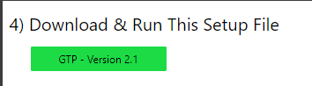
- Download and run the file called “GTP – Version 2.1”. This will launch the installation setup wizard to install the Green’s Test Platform (GTP) software. The WMT and AI are included inside the Green’s Test Platform.
  - If you see a blue window saying “Windows protected your PC”, click on “More Info” then click “Run Anyway”
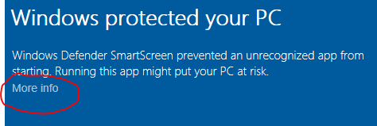
  - If the setup wizard is not shown, look for a little shield flashing or a grey computer icon on your taskbar at the bottom of the screen. Click on this and it will ask you if you want to allow the program to install. Select Yes.
  - If the setup wizard is still not shown, then scroll down to the bottom of the support webpage and click on “Additional Resources”. Download and run the file called “GTP – Version 2.1 (msi)”
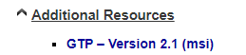
  - If the setup wizard is still not shown, please ensure that your antivirus is not blocking the installation file. You can try disabling your antivirus software and downloading and running the setup file again.
  - If you are installing on a Windows Virtual Machine (i.e. Parallels, Bootcamp, VirtualBox, etc), then you should change the install location from C:\Program Files (x86)\Green's Test Platform\ to C:\Green's Test Platform\
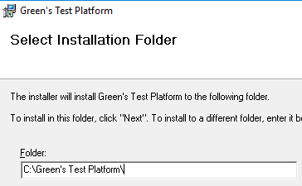
- The setup wizard will update the GTP completely and does not require a registration code
  - If you run into an error during installation that says something about the “.NET Framework” then please go back to the WMT’s support page on our website and scroll down and click on “Required Prerequisite Programs”. You will need to install the “.NET Framework 4.0” and “Update for .NET Framework 4.0” and then try installing the GTP again as described above
- Open the Green’s Test Platform program from your desktop and enter your password
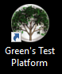
- Verify it says Version 2.1 at the top
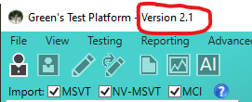
- If you also need to renew your WMT license or add AI credits, then go to Options Enter Registration Code
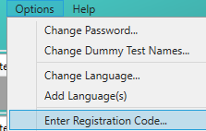
- Send the Psychologist name and both ID numbers to GreensPublishing@gmail.com and then we will send you the Registration Code to enter
