Remove Duplicate Patients / WMT Test Results from GTP

First, you need to determine if it’s duplicated patients or duplicated test results?

This would be duplicated patients (patient name appears more than once in the list on the left):

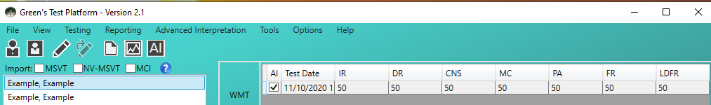

This is duplicated test results (the same patient has two identical test results):

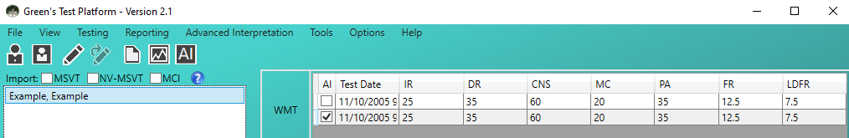

If it's duplicated patients then you can simply delete one of each of the duplicated patients
- Please double-check both patients have the exact same test result first
- To delete, click the patient in the list on the left and go to File --> Delete Patient.

Otherwise, if it's duplicated test results then there's several steps. If you prefer, Green’s Publishing can connect to your computer remotely to remove the duplicate patients for you:
- Go to this website: https://fixme.it
- Click Start Support Session button
- This will download an installation file called FixMe IT Client
- Run the FixMe IT Client file to open the FixMe Program.
  - If you are asked to allow the program to run, click on 'Yes'
- Once the program is open, it will show a Client ID number
- Send the Client ID number to GreensPublishing@gmail.com so we can connect to your computer

If you'd rather do the steps on your own:
- Backup all your current GTP data
  - Go to Reporting --> Export All Data
  - Save the data file to a known folder (i.e. your desktop)
- Close the GTP program
- Follow the steps in the attached "Remove WMT Data From GTP Database"
- Find your backed up data from step #1 and make a copy of it
- Open the Notepad program on your computer
  - If you don't know how to open Notepad, see step #2 from this article --> https://www.digitalcitizen.life/start-notepad-windows/
- In Notepad, select File --> Open
  - You will have to change the selection at the bottom from "Text Documents" to "All Files"
    - 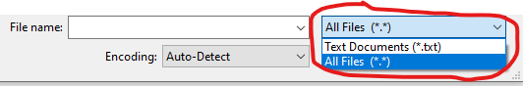
  - Then, locate the copied backup file from step #4 and click the Open button
- Click at the very start of one of the duplicate patient rows
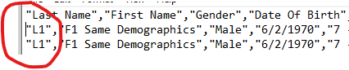
- Hold the Shift key, then press the End key on your keyboard at the same time to highlight the entire row
- Press the Delete key twice on your keyboard to delete the row and delete the empty space
- Repeat the process for all duplicate rows
- Save the Notepad file with File --> Save
- Close the Notepad program
- Open the GTP and enter your password
  - Don't be worried that no patient data is showing
- Select File --> Import From Backup
  - You should then see all of your data without the duplicate test results

