Can’t Login to Support Area of Website

When trying to login to the Support area of our website, one of the following problems occurs:
- There is a spinning circle that keeps spinning, but nothing happens
- It says “Please wait a moment” but then nothing happens
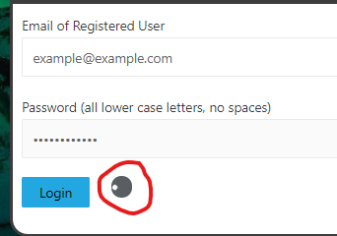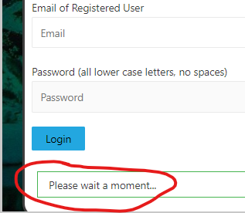

The workaround to solve this problem is:
- Go to this website: https://wordmemorytest.com/wp-login.php?action=logout&_wpnonce=b6d20ec199
- Click on “log out”
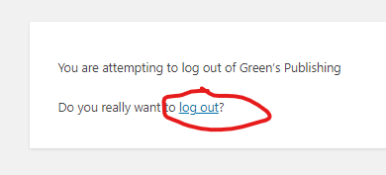
- Wait for your web browser to finish the “log out” then it will take you to a different web page
- Go back to the homepage of our Green’s Publishing website (https://wordmemorytest.com)
- You should then be able to click on “Support” from the main menu and login normally
To avoid this problem in the future:
- Make sure to Log Out of the Support area of our website before you close your web browser by clicking the “Log Out” item from the Support menu
