Join our GreensTests@groups.io User Group Forum (Listserv / Email List)

There are 2 ways to join. You only need to complete either 1) or 2) below:
1)
- Go to this website:
https://groups.io/g/GreensTests
- Scroll to the bottom of the page and click on the Apply button
- Enter your email address in the box
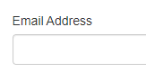
- Click the confirm button
- You will receive an email from Groups.io asking you to confirm your email address
  - If you don’t see this email then please check your spam / junk folder
- You must simply send a reply to that email
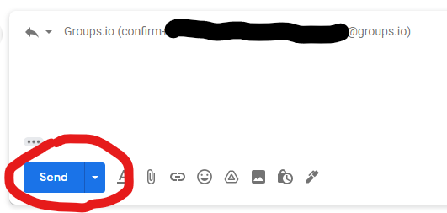
  - You do NOT need to enter any text in the subject or body of the email

2)
- Send an email to GreensTests+Subscribe@groups.io
  - You do not need to enter any text in the subject or body of the email
- You will soon receive an email from Groups.io
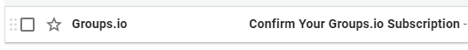
  - If you don’t see this email then please check your spam / junk folder
- Open that email and send a reply to it to confirm your subscription
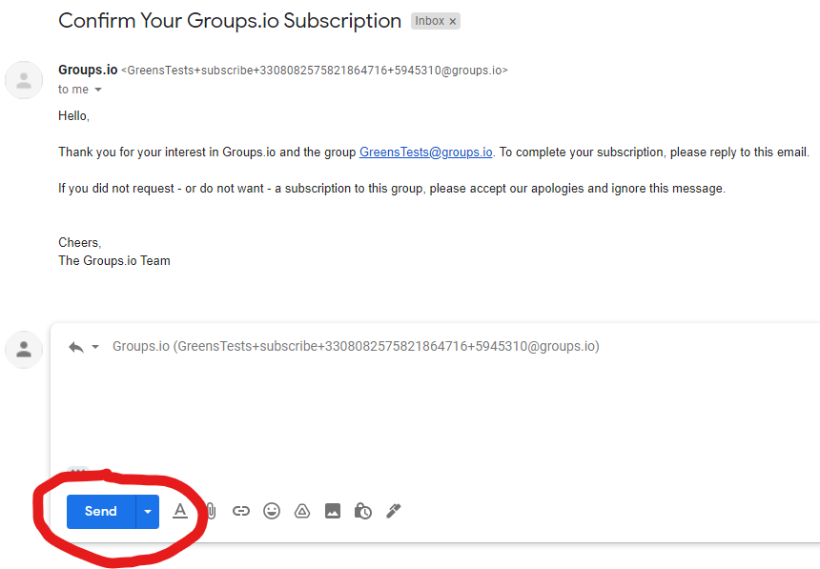
  - You do not need to enter any text in the subject or body of the email

